**Name Sorter**

*Simone Rizzuto*

How to use:

1. Place a file called   
   “*unsorted-names-list.txt”* into   
   “C:\...\NameSorter”.  
   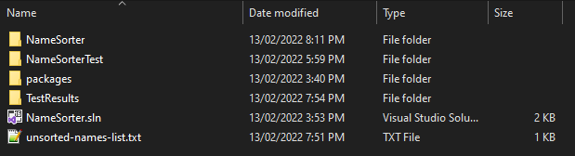
2. Open the app in Visual Studio, and run it normally.   
   A console will pop up with the results of the file.

A new file called “*sorted-names-list.txt”* will be placed in that same directory.

1. Open it to see the results.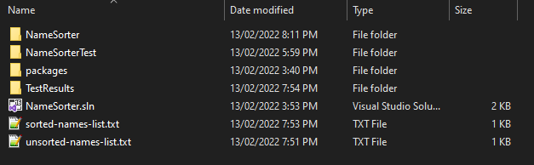

**Note:**  
I apologize if this does not follow what was specifically asked in the pdf. I am not aware of how to make an application that can be run through a command line, so I had to make it run this way for the time being.

Also, there might be minimal unit testing. I am quite inexperienced with working in that, as I am unaware what variables are important to keep track of compared to others. I hope this is an aspect I can also be taught on how to improve on!

Thank you very much. :)